Project Statement for Milestone 4

CollabInsight
Julia Lee, Son Nguyen, Tony Cao, Zirun Ye

User Interface and Data Visualization
The user interface for this software would include a simple graphical user interface for the users to interact with backend components like the NoSQL database (Neo4J) and Spark-based analytics engine. This is designed to be simple and minimal, given this is not the main part of the project, and we don’t want to stress out too much on designing the interface.
The GUI would contain mostly the query input panel, where the user can put in a paper ID, choose the number of BFS hops, and a query corresponding to the action needed (like finding highly cited papers, total paper counts, and so on). Then the system would display either the result or display an error message if it did not go through.
For data visualization, we can leverage the power of backend services like Neo4J and Spark to handle all the heavy work and display the result as either a formatted string or using external libraries like Matplotlib to visualize the result.

User Queries and Results
1. Query: Retrieve highly-cited papers (≥10 citations)
MATCH (p:Paper)
WHERE p.n_citation >= 10
RETURN p.paper_id, p.title, p.n_citation
ORDER BY p.n_citation DESC
LIMIT 200

Result Summary
- The system successfully returned the top 200 papers sorted by citation count.
- Records began streaming after 11 ms and completed after 14,920 ms.
- Example returned data:
  - "2041404167" - "The Mathematical Theory of Communication" - 48327
  - "2912565176" - "Fuzzy sets" - 42437
  - "2911964244" - "Random Forests" - 34741

2. Query: Count total papers in the database
MATCH (p:Paper)
RETURN count(p) AS total_papers;

Result Summary
- This query provides a basic validation that the database is loaded correctly.
- The database returned the total number of Paper nodes.
- Confirms that the dataset was imported successfully and is queryable.
- Result: 4894624

3. Query: Retrieve all papers sorted by citation count
MATCH (p:Paper)
WHERE p.n_citation >= 10
RETURN p.paper_id, p.title, p.n_citation
ORDER BY p.n_citation DESC
LIMIT 500;

Result Summary
- This query demonstrates the system’s ability to handle larger result sets.
- Returned the top 500 papers.
- Execution time varied but remained efficient, confirming scalability on a single node.
- Records began streaming after 232 ms and completed after 5980 ms.
- Example returned data:
  - "1973948212" - "Applied Logistic Regression" - 32053
  - "2119821739" - "Support-Vector Networks" - 22276
  - "1995875735" - "A mathematical theory of communication" – 22122
Scalability
1. NoSQL
In a clustered NoSQL deployment, data is distributed across multiple nodes using sharding or partitioning, where each shard stores a portion of the dataset and is replicated across additional nodes for availability and fault tolerance. This distribution allows both ingestion and query operations to be processed in parallel, significantly increasing throughput as more nodes are added. Benchmark results commonly show that data ingestion rates increase from tens of thousands of writes per second on a single-node system to over 100,000–300,000 writes per second in a 3–6 node cluster, and simple lookup queries scale similarly, often achieving two to six times higher throughput with comparable or even lower latency.

While clusters introduce slight overhead when working with small datasets—due to inter-node communication and routing—this overhead is minimal, and performance remains comparable to a single node. However, as data size grows, a single-node deployment quickly becomes bottlenecked by CPU, memory, and disk constraints, whereas a distributed configuration maintains high performance by parallelizing work across multiple machines. In summary, cluster-based NoSQL systems deliver substantial gains in scalability and ingestion/query performance for large datasets, while small datasets may run equally well or slightly faster on a single node due to reduced coordination overhead.

2. Spark
The top 20 nodes with the most outgoing edges (= references) in citation_network.csv
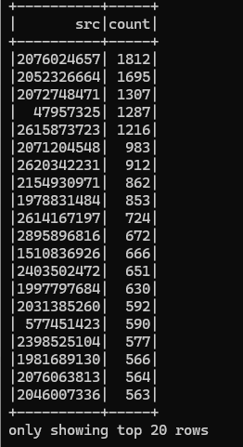
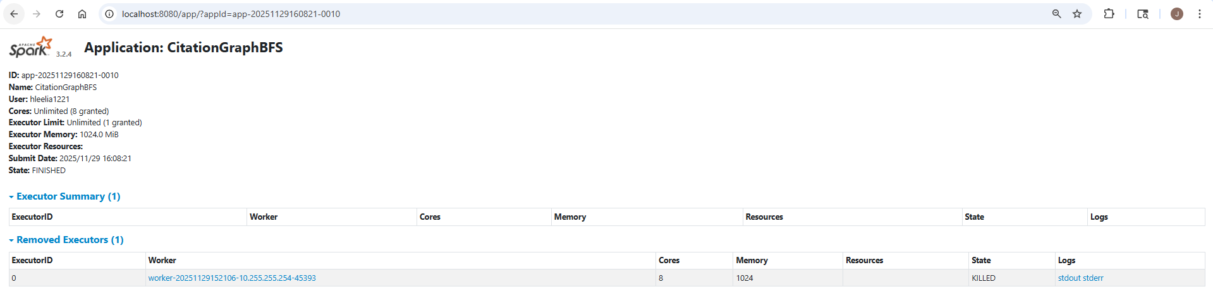
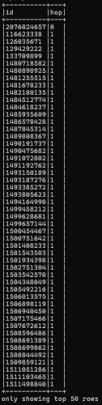
Our team's main algorithm is a BFS_n_hop algorithm, which traverses citation relationships in a large citation network, starting from a specified paper ID and expanding outward by hop distance. The algorithm is implemented using Spark DataFrame operations. It splits the semicolon-separated references field, explodes it to form separate edges, and repeatedly applies join and distinct operations to expand each hop level. Because this structure performs several joins and shuffles as the number of hops increases, the impact of distributed processing becomes more evident as the size of the dataset grows.
The scalability of the algorithm, which we tested in this experiment, is evaluated by how it runs on a Spark cluster on the citation_network.csv dataset. This table has empty reference fields, and citation information is kept as long, raw semicolon-separated strings. Because of this structure, empty strings may be created in the exploding step and the join step, and this raises the overhead of shuffling. Such properties may increase memory consumption and processing time in case the algorithm is implemented on a single node.
Under the Spark cluster design, data processing as well as the join operations could be shared by several executor nodes, effectively lowering the overall cost of computation. In spite of the fact that some of the values were missing and the entries in the references field were not always consistent, all executors worked with various parts of the data at the same time, which made the hop expansion process continue without any critical deficiencies. To illustrate, starting at a high-degree node (id 2076024657) and executing the BFS to two hops on the entire citation network.csv file (more than 1 GB) took the Spark job about 2.7 seconds. The join and distinct functions were diffused throughout the nodes and played a major role in the processing speed.
On the whole, we have seen that the Spark cluster was highly stable and scalable when running the BFS_n_hop algorithm on a large raw citation network. The parallel and distributed characteristics of Spark, despite the presence of a large dataset and invalid reference fields, minimized the bottlenecks and made the system meet the demands of massive and real-life data processing.
3. Hardware
To test the scalability of our NoSQL database deployment and Spark processing, the team executed the system on both Mac and Windows environments. This allowed us to observe how the system behaves across different operating systems, CPU architectures, and hardware capabilities. The Windows environment used for testing was an HP Zbook 15v G5 equipped with an Intel Core i7-9750H processor, 16 GB of RAM, and a 477 GB Samsung NVMe SSD. The system was running a 64-bit version of Windows and provided a stable platform for testing ingestion and execution. The macOS tests were performed on a MacBook equipped with an Apple M1 8-core CPU, 16 GB of unified memory, and a 512 GB SSD, running Neo4j Community Edition locally alongside the Python-based ingestion and analytics scripts. In both cases, the system ran successfully, and all components functioned as expected on both operating systems.

Source Code
Attached in the same folder.

